**DATA STRUCTURES LAB**

**LAB TASK – 1**

**PROGRAM – 1**

**#include <stdio.h>**

**int main()**

**{**

**int n;**

**printf("enter the size of an array:");**

**scanf("%d",&n);**

**int arr[10];**

**printf("enter the elements of an array:");**

**for(int i=0;i<n;i++)**

**{**

**scanf("%d",&arr[i]);**

**}**

**printf("\n");**

**printf("the entered array is as follows:");**

**for(int i=0;i<n;i++)**

**{**

**printf("%d ",arr[i]);**

**}**

**return 0;**

**}**

**OUTPUT :**

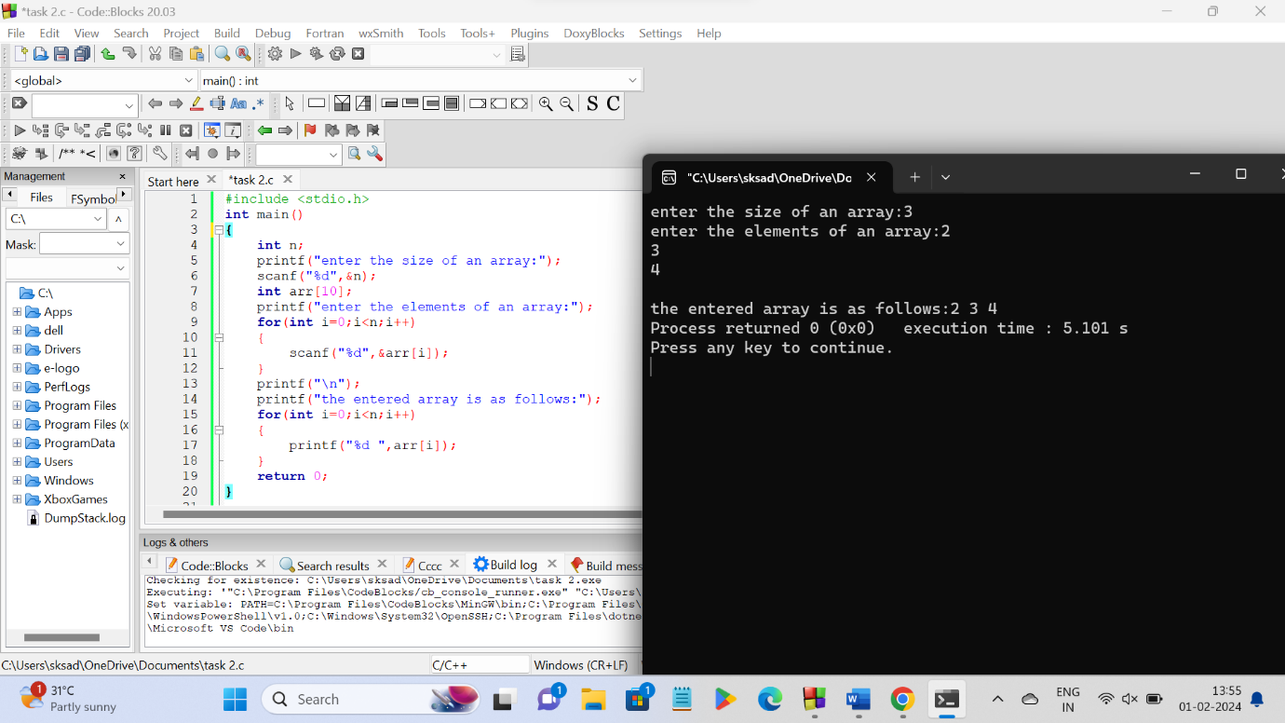

**PROGRAM - 2**

**#include <stdio.h>**

**int main()**

**{**

**int n;**

**printf("enter the size of an array:");**

**scanf("%d",&n);**

**int arr[n];**

**printf("enter the elements of an array:\n");**

**for(int i=0;i<n;i++)**

**{**

**printf("enter a[%d] element ",i);**

**scanf("%d",&arr[i]);**

**}**

**printf("\nentered array ,\n");**

**for(int i=0;i<n;i++)**

**{**

**printf("%d ",arr[i]);**

**}**

**printf("\nreversed array ,\n");**

**for(int i=n-1;i>=0;i--)**

**{**

**printf("%d ",arr[i]);**

**}**

**return 0;**

**}**

**OUTPUT :**

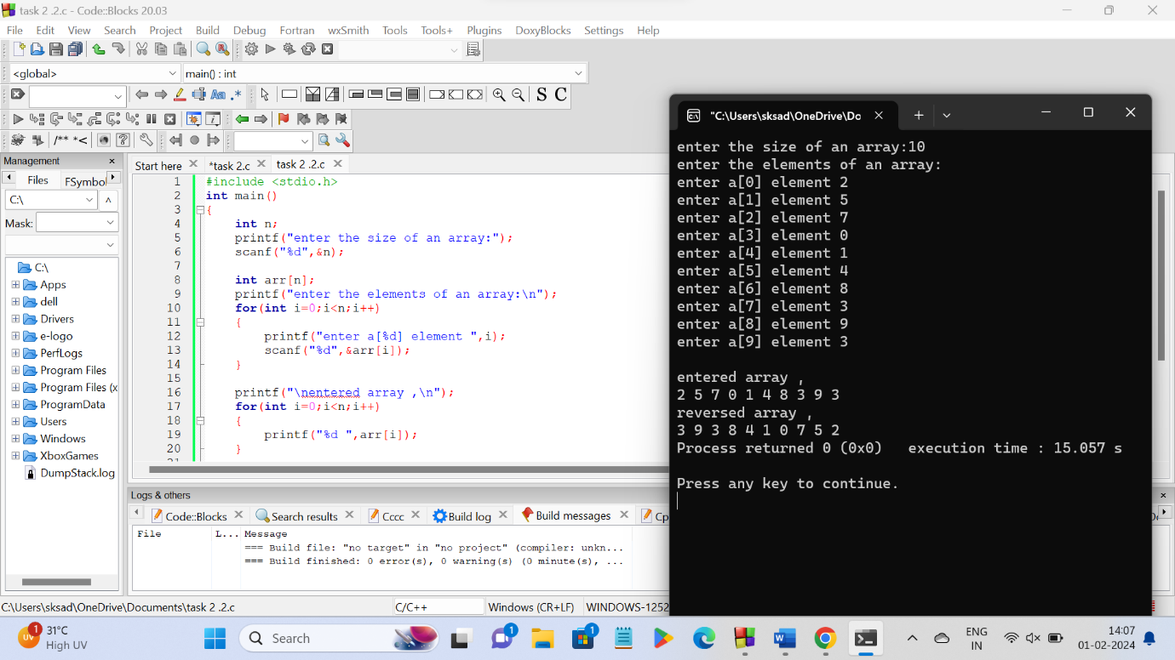

**PROGRAM - 3**

**#include <stdio.h>**

**int main()**

**{**

**int n;**

**printf("enter the size of an array:");**

**scanf("%d",&n);**

**int arr[n];**

**printf("\nenter the elements of the array:\n");**

**for(int i=0;i<n;i++)**

**{**

**scanf("%d",&arr[i]);**

**}**

**int sum;**

**for(int i=0;i<n;i++)**

**{**

**sum+=arr[i];**

**}**

**printf("\nSum of all elements of the array = %d",sum);**

**return 0;**

**}**

**OUTPUT :**

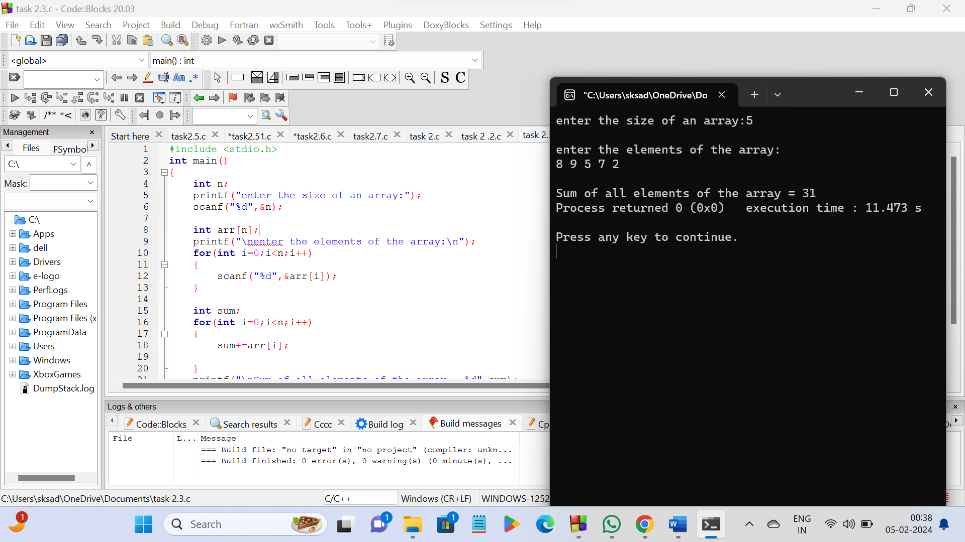

**PROGRAM - 4**

**#include <stdio.h>**

**int main()**

**{**

**int n;**

**printf("enter the size of an array:");**

**scanf("%d",&n);**

**int arr[n];**

**printf("\nenter the elements of the array:\n");**

**for(int i=0;i<n;i++)**

**{**

**scanf("%d",&arr[i]);**

**}**

**int count=0;**

**for(int i=0;i<n;i++)**

**{**

**for(int j=i+1;j<n;j++)**

**{**

**if (arr[i]==arr[j])**

**{**

**count=count+1;**

**break;**

**}**

**}**

**}**

**printf("\ntotal number of duplicate elements in the array =%d\n",count);**

**return 0;**

**}**

**OUTPUT :**

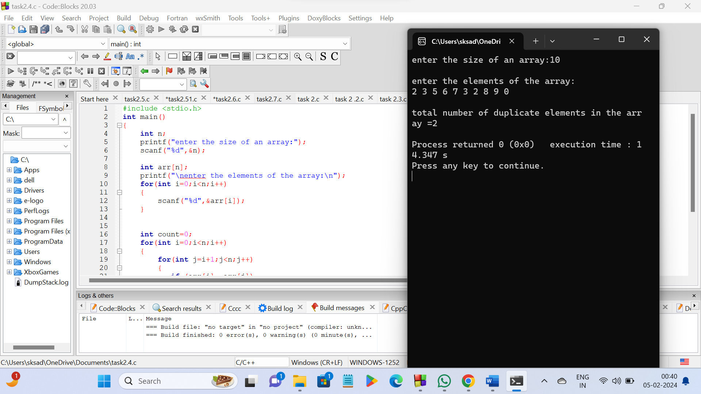

**PROGRAM - 5**

**#include <stdio.h>**

**int main() {**

**int n;**

**printf("Enter the size of an array: ");**

**scanf("%d", &n);**

**int arr[n];**

**printf("\nEnter the elements of the array:\n");**

**for (int i = 0; i < n; i++) {**

**scanf("%d", &arr[i]);**

**}**

**printf("Unique elements in the array: ");**

**for (int i = 0; i < n; i++)**

**{**

**int uniq=1;**

**for (int j = 0; j < n; j++)**

**{**

**if (i != j && arr[i] == arr[j])**

**{**

**uniq = 0;**

**break;**

**}**

**}**

**if (uniq == 1)**

**{**

**printf("%d ", arr[i]);**

**}**

**}**

**return 0;**

**}**

**OUTPUT :**

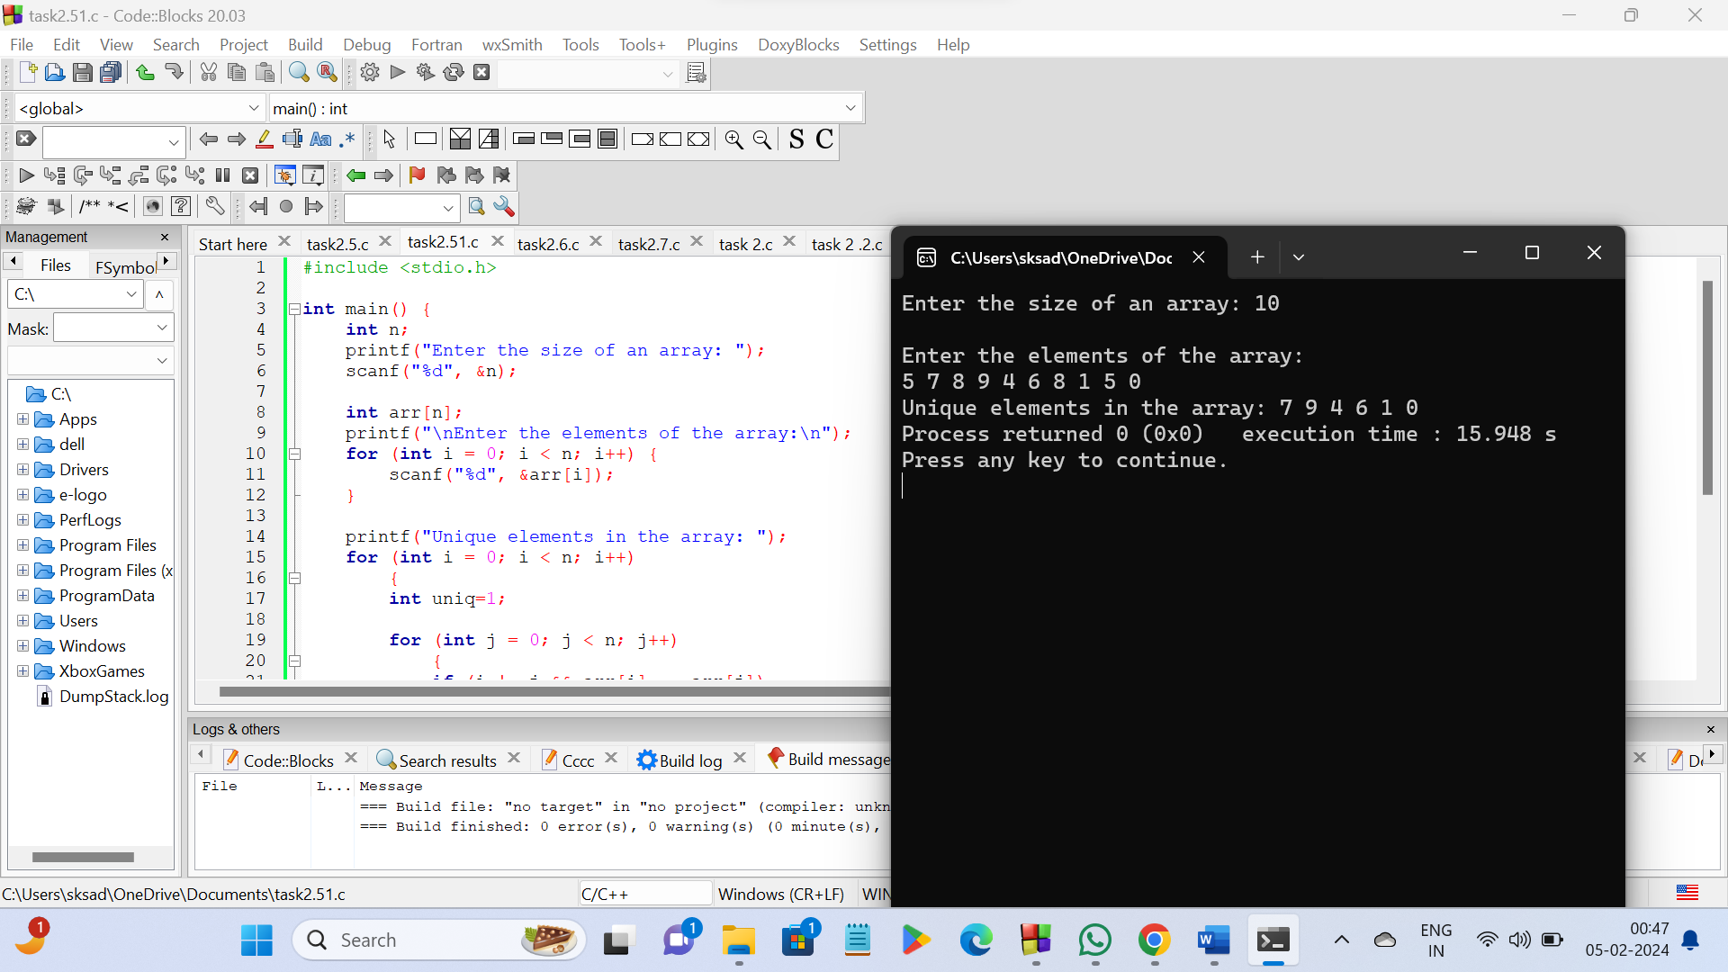

**PROGRAM - 6**

**#include <stdio.h>**

**int main()**

**{**

**int n;**

**printf("Enter the size of an array: ");**

**scanf("%d", &n);**

**int arr[n];**

**printf("\nEnter the elements of the array:\n");**

**for (int i = 0; i < n; i++) {**

**scanf("%d", &arr[i]);**

**}**

**int val,position;**

**printf("\nenter the value to be inserted:");**

**scanf("%d",&val);**

**printf("\nenter the position of the inserted value:");**

**scanf("%d",&position);**

**n++;**

**for (int i=n-1;i>=position;i--)**

**{**

**arr[i]=arr[i-1];**

**}**

**arr[position-1]=val;**

**printf("\nnew array: ");**

**for(int i=0;i<n;i++)**

**{**

**printf("%d ",arr[i]);**

**}**

**return 0;**

**}**

**OUTPUT :**

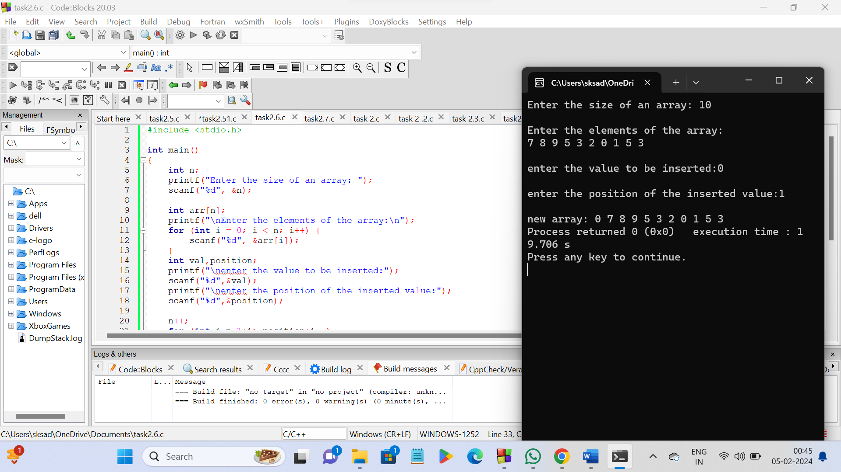

**PROGRAM - 7**

**#include <stdio.h>**

**int main()**

**{**

**int n;**

**printf("Enter the size of an array: ");**

**scanf("%d", &n);**

**int arr[n];**

**printf("\nEnter the elements of the array:\n");**

**for (int i = 0; i < n; i++) {**

**scanf("%d", &arr[i]);**

**}**

**int position;**

**printf("\nenter position of the element in array to be deleted: ");**

**scanf("%d",&position);**

**if(position>n)**

**{**

**printf("\ndeletion is not possible");**

**}**

**else**

**{**

**for(int i=position-1;i<n-1;i++)**

**{**

**arr[i]=arr[i+1];**

**}**

**printf("\nnew array:");**

**for(int i=0;i<n-1;i++)**

**{**

**printf("%d ",arr[i]);**

**}**

**}**

**return 0;**

**}**

**OUTPUT :**

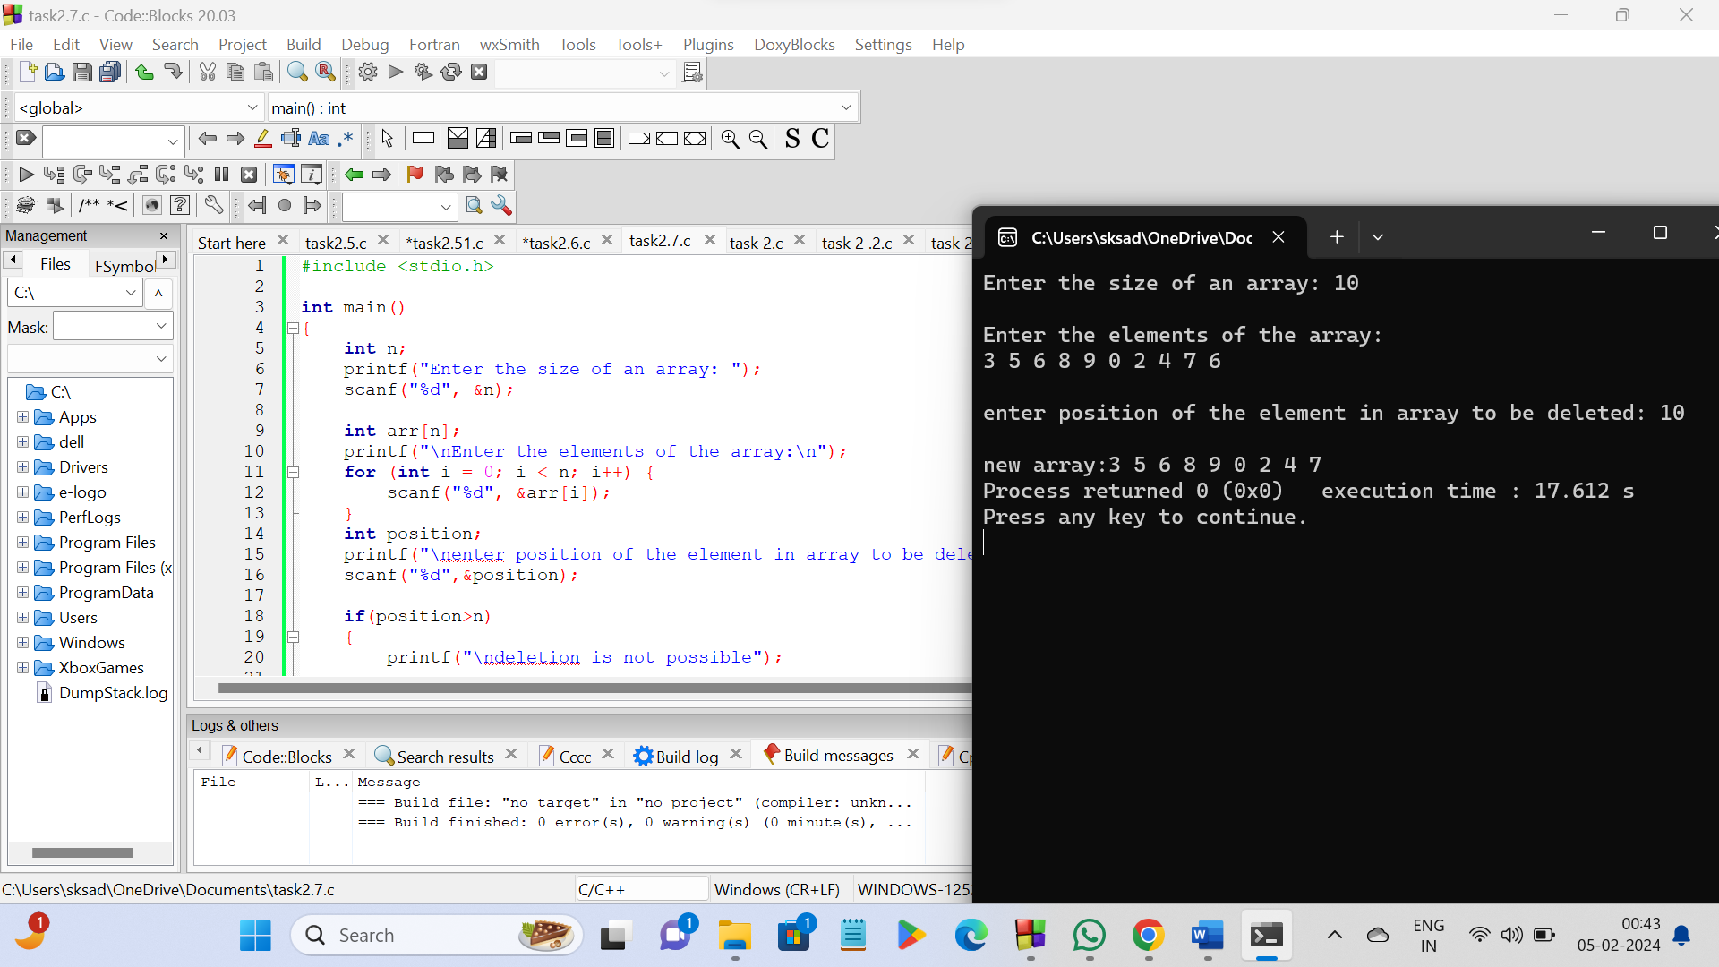

**\*\*\*\*\*THE END\*\*\*\*\***